NORTHERN TERRITORY COMMAND

Most of my B/W photography has been rendered useless over the years by being in storage too long. Much had to be destroyed after moving from Cooktown to Cairns as a result of rain getting into a container. All photographs have been "cropped" due to damage. The "few images of Darwin" were given to me while I was in Samarai Hospital (SE tip of New Guinea) in 1954. A WW2 vet had been bought in from Misima Island in the advance stages of the DT's. He had been also charged with two murders. I can only remember his first name which was Harry. He was in the bed next to mine and while at times he could be delirious there were times when he was well equipped to discuss any subject. He had been in Darwin during WW2 and left in 1946 for New Guinea where he had been a miner before WW2. He was always under police guard at Samarai. He gave me the photographs before they took him to Moresby, Probably because I was a 17 year old soldier. They have not been looked at in 30 years but were dug out when I began to write a manuscript for my children and grand-children. The sequel to Harry is in the PNG section of the Home page.

Images of Darwin 1941-1942

We are ready.
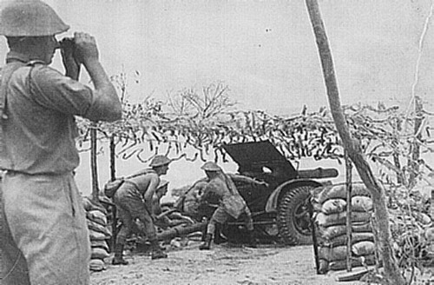

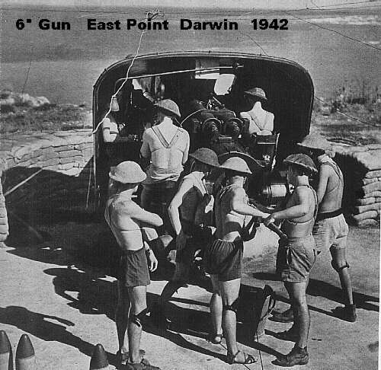

This photo is of a 25 Pdr gun at an unknown beach in Darwin
6” Gun-East Point

Darwin 1945 Smith Street Darwin 1942
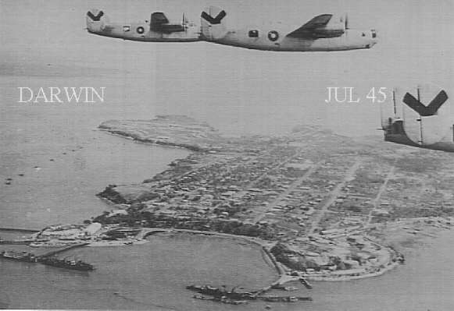

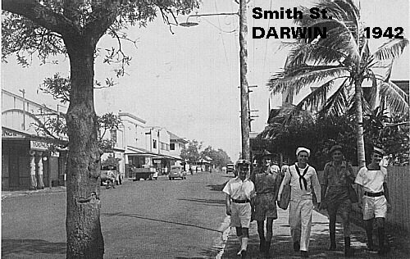

Hotel Darwin 1942
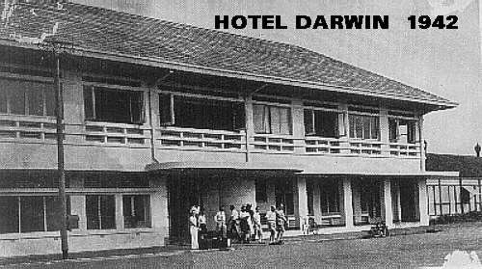

Shortly before the air attack of 19 Feb 42. The people at the front of the hotel are refugees from Java, Singapore and Malaya.

Emery Point tower 1942
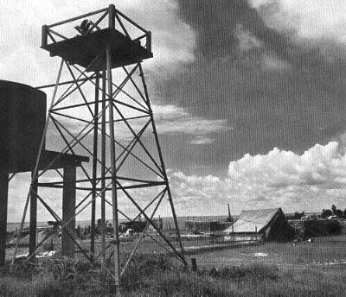

An aircraft warning tower at Larrakeyah barracks. It was close to the road which went down to the slipway where the winch house and store shed for the 'Araluen' were situated. The frame of the tower
was still there during my time in Darwin, but like the slipway was demolished to make way for the RAN base.
Smith St. Darwin, Young’s Garage at left, Vic Hotel
next. Photo taken before the 19 Feb 42 Japanese air attack.

HQ 7th Military District
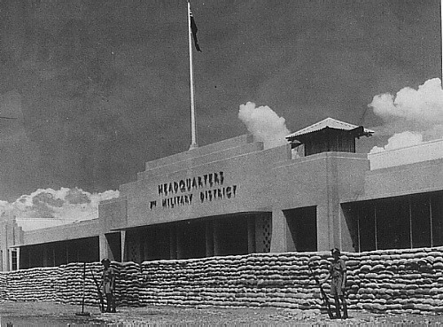

Cigarette shortage – 1942
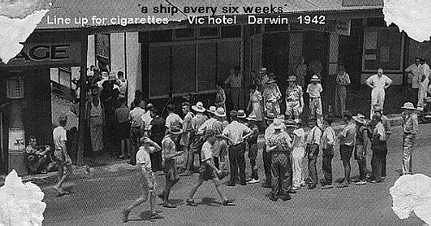

Army Pay Parade – 1942
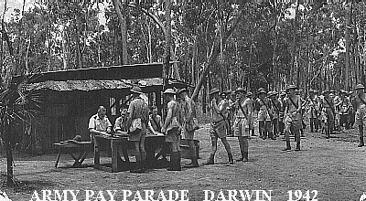

This photograph was taken at an "undisclosed location near Darwin" – 1942
Larrakeyah married quarter

A public relations photograph of a Larrakeyah
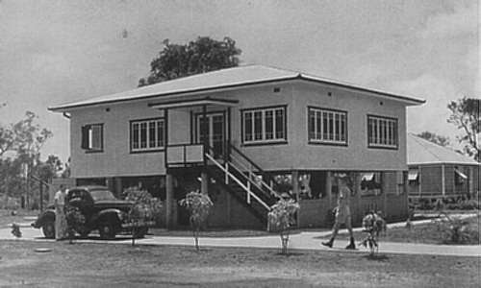

Barracks married quarter, possibly in nurses walk.

Stokes Hill Wharf 1942
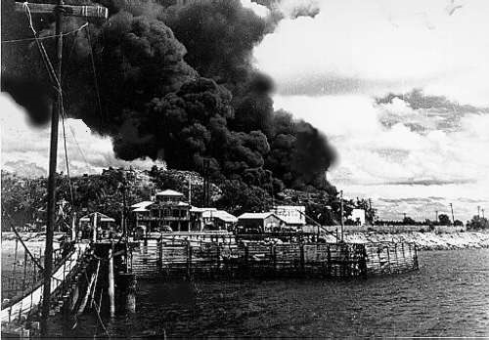

A shot of Stokes Hill, Darwin after the 19 Feb 42 attack. The structure in the forefront is the Flying Boat Wharf used to embark and disembark passengers. On the inside of the wharf the steps were a series of terraced platforms so that the passenger craft could moor at any tide level. The range of tide varied between
22 ft. And -1 ft. I often used the forefront to wash and refuel the ‘Araluen’. We did not have modern refuelling facilities and refuelling was done by siphon from drums held at Larrakeyah. Refuelling was very quickly achieved by using a 1" hose at low tide. The 'Araluen' had a mooring buoy on the inside area of the
main wharf. The wharf was still existing when I left Darwin in 1961 but I believe it was demolished in
1962.

Darwin street 1942
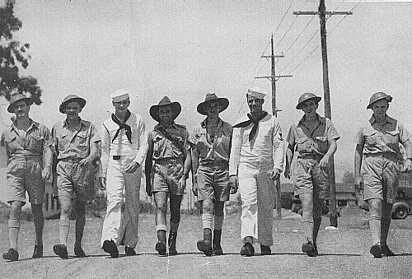

This photograph is of an unknown Darwin street and is obviously a press photo.
Emergency fuel wharf – 1942

This photo is of a temporary refuelling position constructed on the hull of S.S."NEPTUNIA" which was sunk during the 19 Feb 42 Japanese air attack.
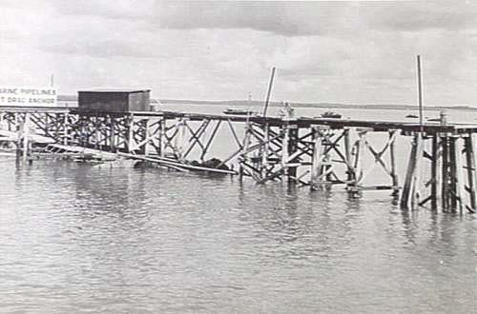

In Nov 1957 I was posted to HQ NT Comd., DARWIN as Coxswain of AM1620 "ARALUEN ". The "ARALUEN" was generally used as a harbour craft only but was to be my first experience of using small craft well outside the designed role. Arriving in Darwin on the Friday night and having settled in at "2" Block I began to ask questions as to the whereabouts of the Sgt. I was to relieve. It was interesting to find that my predecessor had left Darwin as a result of mooring 'ARALUEN' to Delissaville Mission makeshift wharf at high tide and not returning to alter the lines had resulted in the wharf collapsing. It appeared that he left for Perth some time ago "under a cloud", which made me think that as a L/Cpl I would be looked at rather closely. I learnt that the "ARALUEN" was on the Slip way at Larrakeyah and wandered down to have look. It had been sitting on the Slipway for a few months and it looked as though I had quite a bit of work to do. The Slipway itself was left over from WW2 and needed major surgery.

On the Tuesday I was paraded before the Commander NT Comd, Lt. Col. C.P. West and things went smoothly until he asked why a L/Cpl had been posted to a Sgt’s position and my immediate thought was "it's Japan all over again" and I did not have the heart to say that Canberra probably wanted me as far away as possible and that Darwin filled the bill. He wanted to use the "ARALUEN" and, as I was all he was going to get, then so be it.
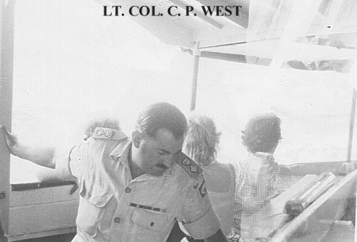

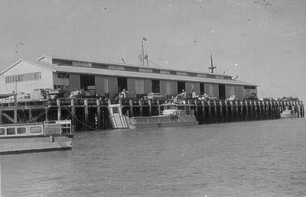
Darwin wharf - 1959

The population of Darwin in 1958 was approximately 10000 and the momentum of development of the Territory had just begun to move with the Uranium mining at Batchelor. Another project that was under way at Humpty Doo, some 30 miles from Darwin, where Territory Rice P/L had 1000000 acres to grow rice. The claim at the time, by some accounts, was that there would be some 10000 people living in the Adelaide River area inside 10 years. The only problem was that thousands of Magpie Geese consumed the seed as quickly as it was grown. Small amounts of explosive were also used to keep the Geese away from the crop but the geese continued to eat the rice paying little attention to the scare tactics being employed against them. The venture eventually failed in 1962 as not only production costs were too high but the outrageous handling charges on the Darwin waterfront contributed to the failure.

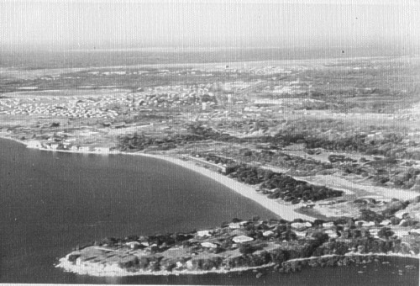
Mindil Beach – 1958

The town area was, naturally, a lot more vibrant than in earlier days although there were still only three hotels in the town proper. The "upmarket" hotel was the "Darwin" and there was the "Vic" in Smith St. and of course the "Don" in Cavanaugh Street. The Darwin hotel was the one to go to if you were courting or having a formal night out. The "Vic" was where you had a drink with your mates and the "Don" was very similar to the "Snakepit" in Port Moresby, if not more outrageous, where you could obtain anything you desire although not necessarily in the order you preferred. There was a hotel at Parap and a new hotel at Fannie

The Forgotten Fleet Northern Territory Command

Bay which was promising as a nice place to go for Dinner. The Buffalo Lodge had a club called the "Buffs Club" on the way to the airport which was very active on a Friday night. There was also the RSL and the Workers Club.
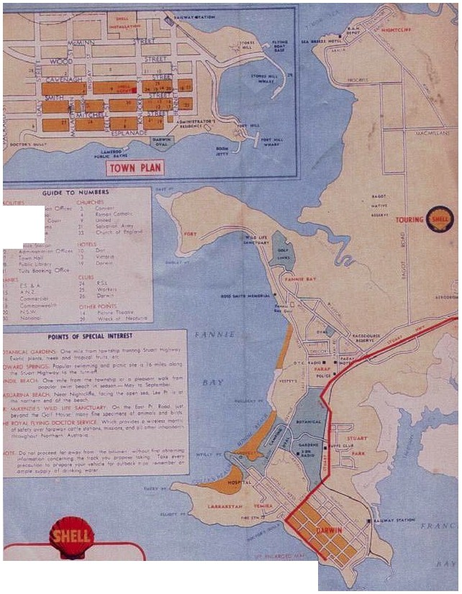

...
..
'.....
.u ._..
,Cit' (.}<1-cf

Darwin Environs

1959 road map

In those days the Post Office was in Mitchell St. and was nothing more than a two story building that seemed to be of WW2 construction consisting of l\.1asonite nailed to a very shaky frame. In 1958 it did have an attraction to Military personnel in that by producing your paybook it was possible to ring anywhere in Australia and have a six minute call for one shilling. More time could be had, at no extra cost, if there was no demand from other users.

"Those who wear white uniforms" (RAN) were headquartered at HMAS "MELVILLE" in Smith St. opposite Christ Church and like the Army were caretakers in the main but also had the Naval Communication base at Coonawarra, outside Darwin. The "operative" service force in Darwin was the RAAF. The airport belonged to them and in 1958 the 5th Airfield Construction Squadron was building the new strip at the airport which was to become the longest strip in Australia. This squadron worked a 24 hour day and were very efficient although that efficiency was maintained by "what we need to do the job -we get". Since much of their equipment was GM powered it did not take me long to see the possibilities and all of my injectors were serviced and repaired by 5 ACS. The RAAF also maintained two Crash boats at East Arm and I never seen much of these boats but when we did meet on the harbour they would always run a circle around me at 25 knots while I was moving at my top speed of eight knots. The boats were the "02" series of Crash boat and were kept in a meticulous condition but they did not go to sea very often. The Navy also had a 40'W/B and it too was in meticulous condition, but it hardly moved from its mooring which was next to mine in the inner portion of the Darwin wharf.

Apart from general harbour tasks, Labour replacement from Bathurst Island and VIP duties there did not seem to be much to do but then recreational fishing was raised and that would take care of weekends. I was posted to the RAE Detachment who carried out all maintenance in Larrakeyah Barracks and I fitted in well and was left alone to do whatever it was I was supposed to do. It took some three weeks to get the "ARALUEN" back in the water and this was accomplished with the assistance of the RAEME Det. led by the WOI I/C, Joe Hines. The boat was painted, new side curtains fitted, engine injectors replaced, new oil and fuel filters fitted, new lagging for the exhausts and replacing some 12 feet of exhaust pipe with heat resisting rubber tubing and the reinstalling of the primary sea water Filter/sand trap which for some reason had been bypassed. When all maintenance and repairs were finalised the next step was placing the Craft Outfit List (COL) aboard and this did present the odd problem. The living aboard continually began to get to me and I proposed to the Commander that every month I would put the "ARALUEN" on the Slipway and have seven days off. This was agreed to and I began to have some sort of social life. There were of course, a few who did not like the idea of me being "different".
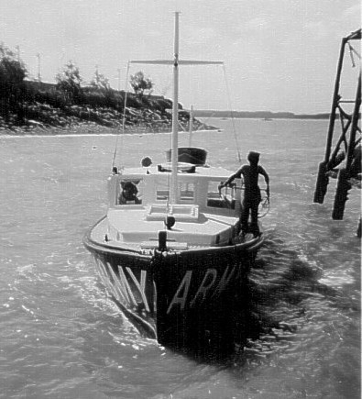

Araluen berthing at the Flying Boat passenger’s jetty at the foot of the main wharf

The "ARALUEN" was moored on the inside of Darwin's main wharf and at this time Uranium was being mined at Rum Jungle. The resultant "Yellowcake" was bought into Darwin by truck and dumped on the foreshore about 100 yards from where we were moored. The Yellowcake was put into piles and remained until a ship came in and the stuff was exported. The smell of sulphur was ever present on board at night and if they were working the pile then the following morning the "ARALUEN" was covered with the stuff. There was never any public indication that Yellowcake was radioactive and to this day I do know if it was dangerous but I believe that the safety precautions today preclude the dumping of Yellowcake on a pile and that it now comes in Containers marked as radioactive material. If it is dangerous now, was it dangerous in 1958, or has it really matured since 1958.

The next little surprise was that the "Boss" had learnt that I was a Navigator Class III and that the establishment called for a Navigator Class II so I was bundled off to Sydney for a week for upgrading to Class II, after I had put the "ARALUEN" back on the slip. I arrived in Sydney during the middle of a course which had four students who were to be trade tested at the completion of the course. I was trade tested rather quickly and although I qualified I began to realise that there was a lot more to Navigation than I had previously thought. I departed Sydney on the Saturday afternoon by TAA DC-4 and returned to Darwin via Melbourne; Adelaide, Alice Springs and Katherine and was back in Darwin seven days to the hour after I left.

The "Boss" now seemed happy but another problem arose. He liked fishing and I did not so we compromised. I began to learn about fishing. When nothing else "was on", we went fishing Wednesday afternoons, Friday nights and on the weekends. On Friday nights I moored the "ARALUEN" to the foremast of the "Meigs"(A US Army cargo ship that was sunk during the 19 Feb 42 attack) and while everybody had a grand time catching large Jewfish I spent the evening studying. On the weekends it was down to Channel Island where there was a hole that nobody knew about (except everybody in Darwin) and on a Sunday it was out to the Five Mile Buoy (Channel Rock) where there was another "secret" hole. Wednesday afternoons was an optional trip where somebody would direct me to a "secret" spot. This "social" or "R & C" schedule was only interrupted if I was tasked on a Coastal task and these tasks became my "R
& C".

Since arriving in Darwin my uniform had been shirt, shorts and sandals but while in Sydney I purchased a khaki Gabardine shirt and had it altered to be worn outside my shorts. Another purchase was a pair of Khaki Gabardine shorts. In Darwin I had picked up an old WW2 type khaki bush hat. I had the NT Command Flash put on the shirt and away I went. The hat brim was starched and it looked rather neat. One day I was queried by the then Command RSM Jim Bolitho about the difference between what everybody else wore and what I was wearing. I respectfully replied that it was common dress on boats. His reply was "OK - but don't let me catch you walking around Larrakeyah looking like a wharfie!” He thought that it had the blessing of the Commander. The Commander when he saw me said "Your dress looks snappy and suitable for your work. Do they wear this type of clothing on all Army craft?” To which I replied "Only when the craft are in the Tropics, Sir". My uniform was never mentioned again. The SAS Squadron had recently been formed in Perth and they arrived in Darwin on exercises. Amongst its members was Clem Keely who I had met previously in Moresby and was a Platoon Sgt. We did night insertions and went around to Bynoe Harbour for a few days on reef work.

SURVEY OPERATIONS

In Jun 58 Central Command Survey arrived and the task was to take surveyors, using "ARALUEN", to various points on the coast between the WA/NT border and the Gulf of Carpentaria where Trig points were established. Each trip would last about 3-4 weeks and the "ARALUEN" would carry up to 12 Surveyors and tow three Assault boats. This all sounded simple at first but when it was pointed out that at 6 gph diesel consumption it would give the "ARALUEN" 40 hours endurance with no reserve or 80 hours if we carried extra drum fuel or unlimited if I could do fuel drops prior to the trip. We did the fuel drops. There was no great problem in this as there was nobody on the coast to steal it at the "dump" locations and the Aboriginals would be at Mission/Govt stations.

My first task with Survey was to take them to designated points beginning at Bynoe Harbour and ending at Port Keat. We set off one afternoon with three assault boats in tow. My Engineer was Jim Taylor (RAEME) who came from the RAEME Wkshps. Jim’s added responsibility was maintaining the Johnson outboards that came with the Assault boats. These outboards were definitely Pre
WW2 and had they been used at Gallipoli the situation there would have been worse. He was a tremendous help to the whole mission. Prior to arriving in Darwin he had been in Trade Repair at Bulimba and as such did the refits of the "TARRA". During WW2 had served at Bulldog building the Bulldog road and had done quite a few trips on the Lakekamu River. We began operations at Quail Island and The DME "Telleurometer"
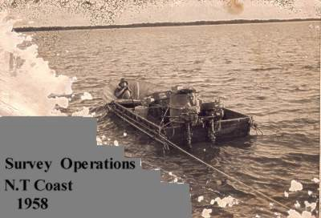

equipment was set up on the peak while I dropped another group on Turtle Island at the bottom of Bynoe Harbour and another at the Eastern mouth of Bynoe Harbour. Quail Island was a RAAF Bombing Range and at that time was a prohibited area. The Island was mainly used by LINCOLN Bombers out of Amberly and although a time block of use was promulgated in Notices to Mariners, no specific time was given. I had advised Survey of this well in advance of the operation. Apparently it had not been followed through as when I got back to Quail Island a RAAF C-47 appeared out of nowhere to buzz the Island to make sure that it was clear. It was usually 30 minutes before the LINCOLN's came in. We had no contact with the aircraft but we did with Larrakeyah and sure enough the RAAF got onto Command and they in turn got onto us. We departed rather quickly and anchored off the Island to watch the show. After it was over I went to pick up the others and the Surveyors decided to continue the next morning but this time the intentions were forwarded to the RAAF. I picked up the party at the head of Bynoe Harbour and we went down to Turtle Island to pick up the other party. They had found the Trig. point and then they departed for deep water awaiting our arrival.

Turtle Island was probably the worst place they could go to. It was alive with the very small sandfly or "Midges" as the Surveyors called them. They were a mess when they came aboard.

We anchored and prepared for the following day. At the Southern and Western ends of Bynoe Harbour was a pass that led out to deep water and now that we were behind the schedule I wanted to have closer look at the pass. The chart simply displayed it as impassable but if we could get through on a high tide it would save hours. The next morning we repeated the process and this phase of the operation was completed. The pickups were made and I anchored about a mile off Quail Island for the night as the Surveyors had to do Star sights to confirm the position. The reason I anchored well off the island was that it was Spring tides and this meant a 20 foot range of tide. To have remained closer would have us stranded for about six hours.

The next morning the Surveyors wanted to check the two islands between Quail and the pass as the present maps and charts were not definitive on outline. They went off in different directions and I headed for the pass. My speed was about 3 knots as I knew that sooner or later I would hit mud and I did so we stopped dead, cleaned out the primary sand filter and went down to the pass in an assault boat. I had a Dumpy Level and marker stave with me and waited for low tide. The night before I computed the time of High and low water on the Admiralty Tide Diagram and drew a tide graph as it was essential to see what time window was available for the transit - if the transit was possible. At the pass it was getting close to low water so Jim hopped from rock to rock and using the Dumpy level it was a rather quick way of determining the rock/boulder that was highest, then applied the next morning’s tide to it, marked the stave and then by using the Dumpy level again found the deepest parts of the pass. The Pass itself was about 50 metres in length and we cut saplings from the island and marked the passage. The saplings were held in position by rocks and we tied two jerricans to the inner and outer markers, just in case the computations were way out.

The next morning we were at the pass 20 minutes before high tide and sure enough the inner marker had disappeared but the outer was still in position. I went through the pass in small bursts of engine power only to maintain steerage as the set through the pass was about 3.5 - 4 knots. We were nearly up to the outer marker when the "ARALUEN" stopped dead and the next thing the assault boats which were being towed slammed into the stern. It was obvious that I had about 20 minutes to get out of this predicament or we were history. The "ARALUEN" was being held between amidships and aft as she was wandering 10-20 degrees at the bow. My appreciation of the problem was that we were being held by a boulder top or we were in a vice -- in which case we were history. I figured that it was a boulder top and moved every piece of equipment that could be moved, forward and then everybody to go forward. The equipment was moved and as everybody went to move forward she came free and was through the pass in an instant.

Anchoring just through the pass the Surveyors were ashore setting up the Telleurometer master station. I realised that I had just had my first lesson in calculated risk and the way my heart was thumping it was too close. I would have to do better in calculating the risks if ever again something like this occurs. After the master was set up we dropped the other parties off down the coast a bit and while waiting for the master station to take readings went and had a look at a few large creeks. All of them had bars and although the "ARALUEN" could enter at high tide there was nowhere to go once inside. At Point Blaze I went ashore with a Survey Spr. (Field Assistant) to have a look around and have some exercise and the terrain was the same as anywhere else along this coast. There would be a sand hill. just beyond the high tide level to about 30 feet high. Beyond the sand hill would be a low lying swamp area before coming to the trees which were about 40' to 50' high and not particularly dense. Walking along the ridge of the sand hills we came across aircraft wreckage and upon further investigation found a lot more. From the wreckage, which was over a large area, it appeared that the aircraft had hit the sand hill while attempting to crash land in the swamp behind or

was attempting a crash landing on the beach and something had gone terribly wrong. We found two engines, one of which still had a cowling and the only aircraft engine that I knew of that had that shape was a B-24 "Liberator". We did not find the other two engines. A bit further down the coast we came across much the same thing but this time the wreckage was in the water about 50 yards out from the low water line and it too was a B-24.

The above was only the start of Operations with the Survey Corps and they continued, every Dry Season until 1960. None of these Operations were without incident and it is now hard for me to put those events of 37+ years ago in chronological order as we worked both West and East of Darwin so I will break them into two main groups.

FIRE

The only major concern I had during Survey operations was fire aboard "ARALUEN". As well as fuel dumps we carried 5 x 44 gallon drums of Dieso as well as 2 x 44 gallons of Petrol. We also carried as part of "ARALUEN's" COL a pressure stove which burned petrol and was to be replaced by LPG (Primus) and was, but not before it caused some drama. The Survey people were equipped with numerous LPG stoves and we used them aboard when the group remained on board overnight: Because "ARALUEN" was always loaded to its maximum with personnel and equipment we had decided early on that a base camp would be set up ashore when circumstances allowed. I carried extra foam- extinguishers but also carried the standard 'CTC' hand extinguisher. Another problem was that of Medical Aid. While the Surveyors were out Surveying in the 'bush' they had a "Flying Doctors" Kit which was the same as those held by Cattle Stations in the Territory. The use of these kits was simple in that when an accident occurred radio contact was made with a doctor who was given the symptoms and then simply radioed back the instructions. i.e. two ounces of bottle "G" mixed with one ounce of tube "L1". Everything was numbered and also had instructions on every possible physical injury. While we carried it on board there was no problem but once it went ashore we were left with the normal issue - a Section medical pouch. I asked for a 'Flying Doctor' Kit as soon as the first trip was completed and was approved and before it finally arrived I was issued with a temporary kit made up in Larrakeyah. This meant that I would only be able to call for assistance from the MO at Larrakeyah as Doctors elsewhere would not know what I had in that Kit and as well I only had a vague idea of what most of the marked packs, bottles etc., contained. This was no problem as our main contact was with Larrakeyah anyway.

We carried an "OONAN" KVA aboard and this was placed over the wheelhouse of "ARALUEN". It was used to charge the large number of batteries that Survey used as well as provide lighting both aboard "ARALUEN" and ashore. Jim Taylor was with me on one trip West of Darwin and he looked after the KVA and batteries as well as everything else mechanical. The weather and sea were perfect and we were going to our anchorage at Peron Island. Jim was "upstairs" checking on the batteries when he found a petrol leak and was in the act of tightening the connection when the whole thing burst into flames. I heard a "whoosh" over the engine noise and a lot of thumping on the deck above me. The engine was stopped and as I was climbing out to see what had happened, a flaming object went hurtling over the side. I thought at first it was Jim but it was only his jacket and overalls. When I got onto the Wheelhouse top Jim was in his underpants and with a small Army notebook was trying to put out the fire. One of the Surveyors came up with a foam extinguisher and the fire was out in seconds. Jim was not badly burnt thanks to his quick thinking in getting rid of his clothes. The incident did bring home one important fact and that was that there was too much

equipment aboard and that Petrol would have to be placed in the Assault Boats being towed but that only raised the second problem, capsizing of Assault Boats.

Another incident occurred at Ruby Island, three miles SE of Cape Hotham. At the time my Engineer was a RAEME Craftsman and he was preparing a meal on the Petrol stove which was in its position just inside the cabin, when it exploded. The resultant fire was put out very quickly but the use of the hand extinguisher, which was filled with Carbon Tetrachloride, created Phosgene gas when it came in contact with the stove which created problems in getting the Engr. out. He had suffered minor body burns but the explosion had seared his eyes. We contacted Larrakeyah and the MO gave us the necessary instructions and I then returned immediately to Darwin. The Engr was taken to hospital and he recovered completely.

On one task in the Port Keats area we had anchored at Peron Island, near the mouth of the Daly River, and on this task I had a wireless Operator from 107 Signal Squadron aboard. Because of the cramped conditions on board "ARALUEN" we decided to make a base camp ashore and the Sig., Cpl Hooley, set up a little base, on the shore, opposite where the "ARALUEN" was anchored. He decided to burn off a bit of the undergrowth and on doing so the resultant fire got somewhat out of hand. Peron Island burned for 36 hours and the Surveyors on the 48' hill had to vacate promptly. The following day the wind increased to
25/30 knots which made the anchorage unusable so I went around to the NW side of the island and found an anchorage in the middle of the rock and reef outcrops. The anchorage was first class with one small problem - I could only get out at high tide. I went ashore at the first opportunity to have a look at a burnt island. Not far from the beach we came across the remains of what appeared to be a settlement but on closer inspection it was obvious that it was either an Army camp or a RAAF camp. No buildings were standing but the concrete floors remained as did the stones marking the 'streets' or paths. There was nothing to indicate who the residents' were but we decided that it had to be a RAAF Radar detachment as the 48' hill was the highest point for some distance. The position of the camp would have been sheltered from the SE Trade winds but they would have been exposed to the NW Monsoon.

At night there wasn't much to do except keep an eye on the rocks surrounding us just to make sure they did not come any closer or become larger. We could not pick up the ABC in Darwin on the radio but we could pick up two stations in SE Asia. The first was a Nationalist Chinese station "reporting" from Quemoy. It was during the period when the Communist Chinese were shelling the daylights out of Quemoy and vice-versa by the Nationalists. The presenter would make snide comments about "You communist swine" or address a message to Mao Tse Tung "Would you like us to send someone over to demonstrate how a knife and fork is used to eat a meal". After each remark, an artillery salvo would fire. It was probably broadcast from a Taiwan studio. Since it was in English, we wondered who the audience would be - apart from us. The other station was in Manila and was a commercial station. For a week, from 7:30
PM every third record played was an orchestral rendition of the "Platters" song "Only You". We assumed that the program manager had a thing going with his wife/girlfriend

While in this area we did some "Croc" shooting at about a mile inside the Daly River. Crocs had been decimated over the years but there were still quite a few around. Even at Bynoe Harbour (next around from Darwin) there were quite a few seen by us at night, and shot at but we did not go to see if we had really got them. In the Daly River we shot four, the largest being 10 feet in length, and skinned them and wrapped the skins up tightly in salt and stowed them on Peron Island as the smell aboard would have been intolerable. We then put two Surveyors ashore at Cape Ford and their task was to set up a slave station for Tellurometer readings. They could not find the original Survey Trig. marker so they lit a small fire to clear

the area but it too got out of control. They quickly found the marker but Cape Ford burnt for several days afterward. What was amazing was that at no time, apart from the Mission and Government stations, did we see or come across any Aborigines on the coast. How very different it was compared to TP & NG where the coast was part of the way of life and of course the means of life and death.

CAPSIZE OF ASSAULT BOATS

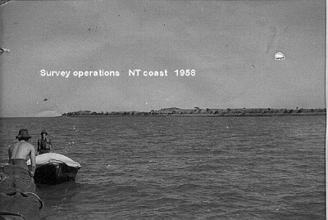

The second problem was that we were continually plagued with the Assault Boats capsizing when underway in moderate to rough seas. At first the boats were towed empty and every now and then in a short sea, they would flip over. As a result of the first fire we began placing the drums of petrol in the towed assault boats, amidships, but this proved useless as although the boats were a lot more stable, the petrol drums would sooner or later come away from the from the lashing that they were tied down with. When, after 2-3 capsizes, we began using Aircraft Tie down equipment and the movement of the drums was stopped. The next application of "Murphy’s Law" was not long in coming. Because we reduced the capsizing by about 60% a lot more strain was placed on the bow of the assault boats by the continual pounding and the short sea. The bow at the towing point gave way. We then ran wire around the whole perimeter of the Assault Boats so the load would spread evenly. That worked but we would still have the odd capsize depending on the weather and being the "Dry" season it was always terrible working inshore due to the short sea which was whipped up by the SE wind.

On one occasion we did not get assault boats but Folding Bridge Equipment (FBE). These little gems, which were obtained from Engineer Sores "down south", were what we had used to put bridges across the George's River at SME Casula when I did my Basic Field Engineer course five years previously. They were perfect in a river but I had doubts about them in the coastal seas of the Northern Territory. They had much higher freeboard than did the assault boats but I still thought they would capsize. We took them on a trip up to the Alligator River and they surprised me, they did not capsize and rode the sea quite safely. The Surveyors then began to load all their equipment into them for the next drop and it was loaded with equipment that caused .disaster to strike - The bottoms fell out of the FBE's leaving a trail of debris 50 metres long as well as the heavier gear going to the bottom. We marked the position, picked up the floating equipment and retired to a safe anchorage to ponder the problem. By this stage I was becoming sick and tired of the whole affair as it was obvious that

the "ARALUEN" was not suitable for the task. I'm sure that we could carry and support one group of Surveyors and one assault boat but not three. The Surveyors did a check of what was missing and we went back the following morning and anchored on top of the FBE which was in 23 feet of water. We then dived on the FBE and astern of it and recovered 95% of the lost equipment. One hazard was the appearance of School Sharks. They were never greater in length than 3-4 feet and they would come racing in and then veer off. We used shark repellent but I do not think that the sharks were told about shark repellent. We never used FBE's again.

The last incident is the one I remember vividly and when. It was August 1960. We were operating in Chambers Bay and the Surveyors were going to go ashore with all the assault boats, build a tower for the Master Tellurometer and then measure the distances to the slave stations. It would mean that the coast up to the Alligator river system would be covered in one continuous operation with the assault boats radiating out both to the East and West. The "ARALUEN" was to be stationed in a central position to assist with any problems that may arise. I had been on this coast before and it was treacherous inshore but so long as I kept an eye on the tide when I was close inshore it would be OK. We had anchored the first day under the light at Cape Hotham and the weather was perfect. The assault boats went to the South and distances were obtained. The area was last surveyed in 1933 by HMAS MORESBY and we had the relevant documentation as to where survey marks were. There was some doubt as to the exact location to Ruby Island and a few Surveyors went across to the Island to find the marker which was put on SW end of the fringing reef. Since it was some 26 years since the marker was put on the reef I thought that the search would be fruitless but after 2 hours they found the steel indicating mark and close to it embedded in the reef was the marker.

I then went across to the Cape Hotham light and went ashore to have a "look see" from the Light Tower. In 1933 the surveying was relatively primitive compared to 1960. Then it was all by line of sight using Heliograph and when that line of sight was established, angles were taken, and then triangulated and distances with positions of the points concerned were then applied and a chart/map produced. The Navy surveyors had run their triangulations from Escape Cliff (SW of Cape Hotham) and in order to achieve line of sight much of the upper growth of trees which prevented line of sight was cut down. A tower was erected at Escape Cliff and a line of sight established. You could not see the Escape Cliffs area as the trees had grown again but the swathe that was originally cut through the trees was still very much in evidence even though it was now about 20 - 25 feet higher.

We anchored that night in the lee of Ruby Island and departed early the next morning for the shore position in Chambers Bay where the tower was to be constructed. Anchoring about 1/4 mile from the beach in barely 1 fathom the unloading began. I was not unduly worried about the tide as it would fall about another two feet before rising and the bottom was deep mud. The "ARALUEN" would be sitting in mud for a couple of hours. The tower frame was unloaded first to be followed by fuel, equipment and finally 10 man ration packs. Everybody went ashore to help erect the tower and I remained aboard. The weather at this point remained fine with a SE wind of about 5 knots and the bay was calm. The tower had been unloaded on the beach and the equipment was loaded into the Assault Boats. At this point the wind shifted to the East and it increased to about 10 knots. I was not concerned as we had done all this before and it was a piece of cake. The boats were reasonably well loaded as they left for the shore. The point of entry was a large creek near where the tower was being constructed. There was a bar but the draft of the assault boats was about 10 inches so passing over the bar would present no problem. The boats had no sooner left the "ARALUEN" when I noticed a shadow appearing on the bay to the East and in a matter of minutes I realised we were in for a "Blow". "Blow" was an understatement as it hit "ARALUEN" at about 30 knots. By this time "ARALUEN" was sitting on the bottom and there was no worry so I got the glasses and

watched the progress of the assault boats. It hit them with a fury and almost immediately the lead boat lost power on the Outboards. The other one came up on the lead boat, passed a line and took it in tow. They only had about 100 yards before they would be over the bar and safe. The wind increased to about 30-35 knots and as the boats approached the bar they were caught in the effect caused by the wind from the East striking the creek tidal outflow. The lead boat capsized and the boat being towed cast off the tow and drifted with the wind finally striking a mud bank. At this stage the "ARALUEN" had heeled about five degrees to starboard but was holding OK. I then radioed to the tower party to get more information but although I could hear them I could not read them. I did not know if all were safe or what was happening with the stranded boat. I remained in my anchored position all night and was calling on the radio every 10 minutes and the wind had increased to approx. 40 knots. The anchor had started dragging even with extra line out and the only lights I could see were own. The lights were extinguished at intervals so I could use the glasses to determine if there was a fire on the beach but I could see nothing. did not have a clue where I was relative to the beach and kept raising the anchor and going back to where I "thought" my original position was. I also fired illuminating flares, not so much to find the beach group but rather to let them know where I was.

All food was still aboard and that was no consolation to me. That night was very, very long. At daybreak I found I was about 3 miles from the drop point and I returned to the same spot again and anchored. There was no sign of anybody so I raised Larrakeyah on the radio and told them what had happened and I would nose into the beach an hour before high tide. The sea was a murky brown with white caps everywhere and the sea disposition was short with wave height 4-5 feet. Nosing onto the beach I could see no one but one of the boats was on the beach at high tide level and was moored but I could not raise anybody and I began to get a little angry because it was obvious that whoever was left had moored one of the boats and then left the beach. I remained on station until about 1400 and then radioed to Larrakeyah that I would have to return to Darwin as I was wearing out fast and the wheelhouse Port window had been smashed during the night by the anchor hatch cover being picked up by a wave and hurled against the glass. I was then advised that the party had walked to "WOOLNER" station and radio/telephoned Larrakeyah. Thinking that somebody would come back to the beach I remained until 1600 and then departed for Darwin arriving at midnight. Not much was said about that trip but it was obvious to me that "ARALUEN" was not suitable for the task due to the size of her relative to the amount of equipment carried and the number of personnel and the assault boats were not a raging success.

On one trip assault boats and FBE's were not available but the Survey people had bought along two sections of an Infantry Foot bridge, Assault, Pontoon. It was made entirely of aluminium and very light and very useless. We took it along but it was only used when, in perfect weather, I would nose in on the beach as far as I could go and then load equipment onto the "raft" and Surveyors swam it ashore. I had a great admiration for Central Command Field Survey as these people were very keen and professional in their work and put up with hardship in the field that lesser people such as the Public Service counterparts would not accept. Their O.C. Major Frank Buckland was a fine dedicated Officer who drove his men hard but also recognised fair play. He and I did not see eye to eye on a few matters but I did

realise
that he was on a time schedule and every time there was a 'foul up' it meant
that

something had to go on next year’s schedule.

BATHURST ISLAND LABOUR RECRUITMENT

The Army in Darwin employed many native labourers and every three months or so we would return the native labour to Bathurst Island and take on a new group. They had their own barracks down on Emery Point and would only receive a portion of their pay each pay-day- The remainder was accrued so that at the end of their time would have quite a tidy sum. They would be loaded on board at about 0400 and then go across to Bathurst Island entering Aspley Strait about 0700. Also on board would be a Paying Officer and on some occasions it would be the RSM or Dal Wilschefski (Workshops IC).

On my first trip across to Bathurst Island the paying Officer was the RSM Jim Bolitho and the trip across was very pleasant. On the return that afternoon the weather was typical Dry season, a SE wind of about 25 knots and the normal short, steep sea. Jim spent the entire trip from the Southern bar at Aspley Strait to the 5 Mile Buoy hanging onto the mast and popping "Kwell" seasick tablets into his mouth like they were going out of fashion. Needless to say he kept bringing them up again.

MILLINGIMBI LABOUR RECRUITMENT

In August 1958 one task that was never completed was a trip to Milllingimbi to recruit labour at the Mission. The personnel aboard were Maj. John Walker who, as the Larrakeyah Camp Commandant was the Recruiting Officer, Bruce Byron as the Engr, Cpl Fred Bath as the wireless Operator, Spr Neville Flanagan and myself. We left Darwin at 0400 with full tanks and six extra drums of aboard. The passage to Clarence Strait was superb with calm seas and little wind. Passing East Vernon Island the wind increased and about two miles West of Cape Hotham the weather did a complete change into a near Gale. About an hour later the boat was wet through completely, caused by the natural urge of "ARALUEN" to go through and not over the short and steep sea. Another hour later and the mast came crashing down.

Hoping that as we drew away from Cape Hotham that the sea would subside, I kept punching into the sea but at reduced speed. We reached Cape Don about 1600 and were behind schedule and still being battered so I decided to go into Port Essington and dry out the boat and us before continuing as well as hoping for the weather to ease. We intended to go right into the inner part of Port Essington and anchor at the old site of Victoria the first settlement on the Northern coastline of Australia. However going past Smith Point the steering gave way and we hastily anchored. The steering cable on Workboats leaves the wheel and enters a guide pipe enclosure and runs down the Stb side to the stern. The cable had parted inside the pipe. There was nothing we could do except rig the Emergency Tiller but to carry on to Millingimbi

and return was pointless in the prevailing weather
conditions so contact was made with

Larrakeyah and it was arranged for a Lincoln Bomber to airdrop SWR cable to us at Smith Point. In the meantime we stripped the boat bare and everything including lifejackets were either wet or covered with dry salt and

Peter James Bayliss, 1992
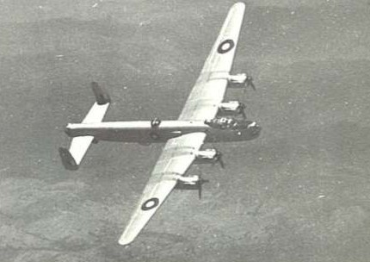

The trace of diesel exhaust. The Lincoln arrived the following day and the airdrop was made on the beach about 30 yards from the "ARALUEN" and with it came a dozen cans of cold beer. The repair was completed and we took "ARALUEN" on a test run and no problems were encountered. We departed Port Essington the following day and the weather was waiting for us and I entered Bowen

51

Strait, between Croker Island and the Mainland.

On the way down Bowen Strait I kept looking to the mainland to see if there was a clearing or evidence of settlement. In 1884 a fellow by the name of E. Robinson was appointed by the South Australian Govt. to collect Customs duties and licence fees from Macassan (Indonesian) fishermen. The Macassans would come south from Indonesia and make a landfall at Melville Island and then go across to Cape Don, Port Essington, Bowen Strait, Goulburn Island, Elcho Island and Groote Eylandt, collecting Trepang and trading wine, tobacco, mother-of-pearl and horn. Since they were making a profit and the Aborigines were making profit the Govt. decided to get into the act and charge fees for entering Australia. The "Revenue station" continued for five years. It was this "station" that I was looking for but all that was sighted was two Aborigines on a beach. It was, in fact, the only time I ever seen Aborigines on the coast of the Northern Territory, away from Govt. stations or missions in four years.

One 'snippet' of trivia was that here in the Port Essington area and along the rest of the NT coastline was evidence of foreign incursions. We would come across campsites on the beach that were definitely not Aboriginal nor were they of European origin. These sites were reported but who and what was going to check them out as Australia at that time had no Surveillance system operating. Apart from ourselves the only craft that landed on the Coastline were Ningle Haritos (barramundi), Leo Hickey, the odd Oil Exploration vessel and Mission Craft.

Leaving Bowen Strait we then crossed Mountnorris Bay and found a below average anchorage in the Lee of De Courcy Head. There was no abatement of the wind during the night and Maj. Walker was becoming concerned about the weather, relative to the conditions that would be aboard if we had 15 natives on board. I assured him that we would not meet these conditions every time the trip was made to which he replied "once is bad enough". We departed the anchorage at 0530 and made for Goulburn Island and the weather was worse than it was the day before. RPM was down to 1000 RPM and "ARALUEN" was being thrown "every which way but loose". About 0900 we had not progressed very much at all and Maj. Walker decided to call it a day and return to Darwin. I was disappointed to say the least but there was one factor that was nagging at me by this stage and that was that fuel for the trip had been calculated at the trip plus 25% and that reserve had been reduced to about 15% and we did not know if we could pick up dieso at Millingimbi. I knew that running with the weather would be a pleasure more than a chore and going eastwards we were past the 'point of no return' but Maj. Walker was adamant so I turned and headed back to Darwin non-stop arriving at midnight.

In 1959 a series of promotions took place. One day I was a L/Cpl, the next day I was Cpl and the week after was promoted Sgt. and the workload of fishing trips increased. They were boring affairs but they at least meant I could carry on with my study which was going ahead smoothly now that Spherical Trigonometry was no longer a mystery. I could now find eight stars at a glance and was now not only been able to do the Marq St. Hilaire method of placing a position line on a chart (with some degree of accuracy) but also a Longitude by Chronometer. The equipment of the "ARALUEN" did not include a Chronometer and I obtained all time signals from WWV in Washington or WWVH in Honolulu and then pre-set the second hand on my watch to obtain GMT.

By mid 1959 the "ARALUEN" was now well equipped with spares, none of which were authorised on the COL. In fact the only authorised item on board were the bulky yellow life jackets and if I could have "obtained" replacements for those then they too would go ashore in

the little shed/workshop that was on the beach near the slip way and totally covered by bush. Carried on board "ARALUEN" as extras were two sea water pumps and five spare Neoprene impellers, two spare starter motors, one complete set of injectors, a very extensive tool kit which was on "loan", an AS W510 radio which was backup to the "Australphone", The "Flying Doctor" medical kit, two 10 man ration packs, a spare 12V/21 plate battery, a very powerful spotlight, extra foam extinguishers, Carpentry tools, an extra CQR anchor, two reef anchors, a Marker buoy and 12 x 12' x 2" lengths of timber used as markers when having a look at a river/creek entrance. By the time "ARALUEN" was loaded with fuel, passengers and their equipment there was very little space left. "ARALUEN" was now being used for every conceivable task that could be thought of, ranging from the Long Range Operation to a picnic on Mica beach at Talc Head, fishing trips to Bynoe Harbour and Melville Island and harbour tours. This all suited me but it was the long range jobs that worried me as I was operating too far from base support in relation to problems which we could not handle on board. My education in the field of going where "angels fear to tread" was 90% complete and the remaining 10% was the unknown and wariness of the unknown prevented making a fool of myself on many occasions. Calculated risk was the name of the game and I was at a stage where I could say "Yes.. we will" or "No.. we will not" and be correct.

I now became an addict to Long Range Operations (my own term) and knew that "ARALUEN" could carry them out successfully but only as a singular task. The problem was that every time the singular mission was conceived it very soon became a multi mission and that sooner or later would end in disaster as it introduced independent variables to the whole equation. A case in point was that I wanted to do a trip down to Wyndham in WA and approached the Commander NT Command as to the possibilities. The reason for the trip was to have a look at every creek, river, island and bay West of Port Keats to Wyndham as very little was known of this coast. The idea was warmly received but before long extra tasks were to be included and more personnel would be going, as well as others who had heard of the trip wanted to either go or "could you do this" or "could so and so be dropped off at Daly River on the way". A 40' W boat is good but to carry out these multi missions would either require more Workboats or a larger craft and we were not going to get either so I did not encourage any more of these single missions which became multi missions overnight.

After I was promoted Sgt, a few more doors opened to me. Transition to the Sgts. Mess was no problem but there was uneasiness about leaving the close confines of the RATTEY CLUB. NT COMMAND in those days was more of a "Caretaker" Command and there were very few Regimental positions. There were a few "named" units such as 107 Sig Sqn. 107
Transport Pl., 107 Supply Pl. and the local CMF Coast Artillery unit at East Point. None of these units were of any great size in ARA personnel, the largest probably being the Transport Platoon with about 15 all ranks. There was also the RAEME Workshops with about nine personnel, RAE Det. with about 12 personnel, Ordnance Det. with Three personnel. Command HQ was the same as any Command HQ with the same sections as the other Command HQ's except that many of those sections contained only one incumbent. There was also the Command Pay Office/Finance Section which was civil staffed and the Canteens Service. Consequently the Command was a family of very different people and from all Corps. Everybody got on well with each other and in my case, during my time in the RATTEY CLUB, the assistance given to me by the OR's was first class. Since I was a "one off" and the ARALUEN was a "one off" were times when I needed assistance outside the normal duty hours of the Command and the OR's would give me a hand irrespective of the time of day. One of the soldiers that I was friendly with at Larrakeyah was a Gnr. Cubillo. He was serving with the CMF Artillery unit at East Point. We only saw each other occasionally but there was a smile and a willingness to help out on any problem I had. He was probably of either Malay or Phillipino descent but we got on well together. He is one of the Darwin

residents that I would like to meet again one day. My duty hours during the posting were "non defined" and simply put, meant 24 hours a day and seven days a week. These hours were also compounded by the fact that during the Wet Season I lived aboard the ARALUEN. Although I had a Bathurst Islander as deckhand he lived ashore during the "Wet" and aboard during the "Dry".

The RSM of NT Command at the time (1959) was W01 "Matey" McGlaughlin M.M. and whereas I could wear sandals with my 'uniform' at the Rattey Club (OR's mess) the RSM would not allow it in the Sgts. Mess so if I was going to have a drink at the bar I would have to change my sandals to either Boots and Puttees or shoes with long socks. There was no way I would wear Boots and Puttees and I did not like long socks. The RSM compromised and said “either put long socks on or don't bother coming into the bar! ". There was some logic in what he said and I took his advice. He spent the next 12 months telling me to either pull the left sock up or the right sock or both as they kept falling down.

I shared a room in the Sgts. Mess with "Dusty" Miller, a S/Sgt pilot of the yet to be conceived Army Aviation. After reception in the Sgts. Mess by the RSM, "Matey" McGlaughlin, I then proceeded to carry on as before but not before the RSM put me "in the portrait" as to what was expected of me. My uniform of the day was always the first topic of conversation on these occasions. The conversation boiled down to two points: l. What my "uniform of the day" was outside the Mess was a matter for discussion and 2. What my "dress" was to be in the Sgts. Mess was not a matter for discussion but one of direction.

He then informed me that as I was the junior Sgt. in the mess I was also the Vice President of the Mess and as a Formal Dining-in night was being held the following week there were certain functions the Vice President had to carry out on that evening - the main function being to "toast the Queen". To carry out these functions he told me that I would finish work on that Friday evening at 1630 and be dressed and ready at the foyer to receive guests, with himself and Elsie (his wife) at 1800. I was not to finish at 1800 as I usually did and wander into the foyer on my way to my room looking like "something the dog dragged in" and begin talking to members and guests. On the evening I had carried out my instructions to the letter and the RSM said I looked "reasonable" which, coming from him was a very high compliment. As Members and Guests arrived they were met by us and then went to the upper area near the balcony where Sherry and "tit-bits" were served. When there was an interval between guests I would go upstairs on some pretext and have a few sherries. I could not bear the thought of the waiters carrying a tray full of glasses of Sherry and having no one to give them to. The evening was a complete success although there was an anxious moment when the "passing of the Port" was carried out. By the time the RSM arose from his chair and said "Mr. Vice", the contents of my glass had disappeared so I arose and covering the glass with my hand and gave my speech which had been put to memory over the preceding week and said "Gentlemen, the Queen" and went through the motions of drinking from my glass. I felt sure that the RSM did not notice but in retrospect I believe he did but did not say anything. The sooner another Cpl. was promoted Sgt. the sooner I could get back to normal.

THE DARWIN WRECKS
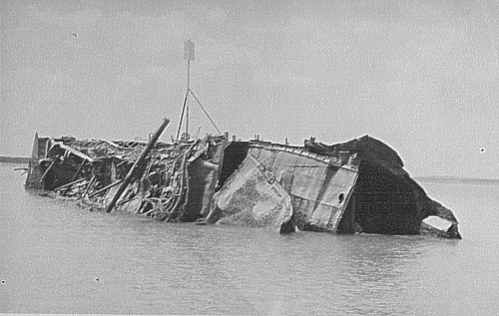

The "NEPTUNIA" alongside Darwin wharf – 1957

The wrecks in the harbour gained my interest as it was a certainty that I would be doing "tourist" trips all over the place. There were six wrecks altogether. "Neptunia", "Zealandia", "British Motorist", "Meigs, "Mauna Loa" and the USS "Peary". All had been sunk on the 19th February 1942. The Peary was totally submerged. The Salvage rights for the wrecks was obtained by Carl Atkinson of Darwin and he sold the rights to the Fujita Salvage Company, a Japanese Company. The Japs arrived and set up a camp near the old Flying Boat wharf and quietly went about their business. The salvage operation was time consuming and many people wondered just what they were doing as nothing much was seen except portions of the "Zealandia" were put ashore. I watched with some interest to what was going on and often when on a fishing trip the "Boss" would have me detour around the "Meigs" or the "British Motorist" to have a "stickybeak". They literally blew the "Meigs" apart, section by section, starting at the Bow. They used Plastic explosive and would split long lengths of Bamboo and then line the Bamboo with the plastic explosive. The lengths of Bamboo were then fastened to the hull in the prescribed pattern and then exploded. Divers would then use a combination of Oxy cutting and explosives to separate large sections. Many of these sections ranged from 60-
100 tons. The "Meigs" was originally bound for Java but was recalled to Darwin, arriving the day before the raid on 19th February 1942. It would have been interesting to see some of the cargo as it was bought ashore but most of it was destroyed during the raid or was destroyed during the Salvage process.

Of particular interest was the activity going on around the "British Motorist". There seemed to be more divers and equipment on the wreck than all the others. We then learnt that there would be an attempt to raise the wreck and use it as an operations and accommodation base. The ship had been cut in half and it was hoped to raise the forward section. The only announcement made was that a trial "raising" would be held to determine the suction holding the wreck in the mud. I went over with the "ARALUEN" to watch. The Japs started pumping early in the morning and about midday the "British Motorist" popped to the surface and was riding high. Whether it was a trial or not was academic, the reality was already floating. The Salvage crew spent a week cleaning and patching before moving the whole operation aboard. When the removal of the other wrecks was completed the "British Motorist" was then cut up and the whole mass of scrap metal, some 12000 tons, was taken to Japan to possibly become the Toyota and Datsun cars of 1961. The "Peary" was regarded by the United States as a Cemetery/Memorial and as far as I know has never been touched, least of all by a Japanese Company.

In Jan 60 I went on leave but before I left I put the "ARALUEN" on the slips as it was "Wet Season" and to have left her on the buoy during a blow would be disastrous. I usually had help to put her on the slips but this time there was no help. First of all I ran the cradle down to its extremity at low water and then went around to the wharf and then took the "ARALUEN" around to the slipway to wait for the tide. When the tide was high enough I then put her into position in the cradle moored her securely and then dived overboard, swam ashore and started the winch and bought her slowly in and then swam out again to check her position on the cradle and repeated the process until she was OK. Once she was winched in to the stop point she was then stripped of everything, washed down and scraped if necessary.

My main reason for going to Sydney for leave was to buy a new Ford Zephyr and on arrival at Broadway Motors the day after I arrived I was disappointed to find that I would have to wait two weeks. I then began placing 1,320 pound in 10 pound notes on the table (the cost was
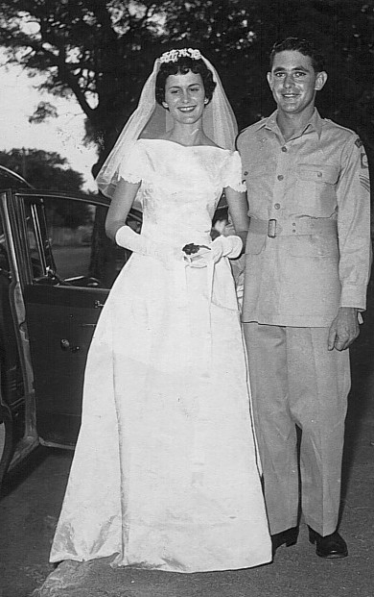

1,320 pounds) and I had my Zephyr in three hours. While in Sydney I went out to Chowder Bay to have a look at the new LSM s that had recently arrived from Japan. I remember being impressed by their size but with 48 crew wondered what was happening to Water Transport. I was quite happy with the "little Ships". I intended to drive back to Darwin but after leave left the car in Sydney and flew back to Darwin.

On Sep 30 1960 Suzanne and I were married in Christ Church, Darwin. As I was scheduled for long trip in ten days I was allowed the use of the "Araluen" for our honeymoon as well as using the Commander N.T. Command’s staff car as the wedding car.

During one of the weekend fishing trips I had anchored on a hole about a mile West of the Five Mile Buoy and
everybody but myself were busily engaged in pulling fish in when I noticed a squall on the way. I had been in open, at anchor, before and they were no great problem but this one was very short and very violent in its passing and it lifted the Anchor Hatch cover and tossed it over the side and for some reason I then did something that I had never done before and have never done since.--I went over the side after it and the problems began as soon as I reached the Hatch Cover as swimming with the Cover back to the boat against the current was futile--I was going backwards. Dal Wilschefski, the RAEME Wkshp. OC was aboard and he started the engine, raised the anchor and the "ARALUEN" drifted down to me to a point where I let the Cover go and swam to the boat. I then went and picked up the Cover. The only "plus" for the whole episode was that I did not lose the Hatch Cover. The fishing trip was for the Officers Mess and the DAAG was aboard.

On the Monday morning I was paraded before him and he told me that he was considering charging me with "leaving my vehicle unattended". It was foolish to go over the side after the Hatch cover but I could not resist laughing at this statement (inward, naturally).

TARGET TOWING

Target Towing was another of the tasks that I undertook and, I might add - the original purpose of "Araluen", at times provided comic relief. In Sydney we had towed Splash Targets at 18 knots with AV2770 "SANDRA" off South Head and the "Splash" or "Plume" which was the aim point was about 10 feet high and quite visible by day and very visible at night with the searchlights. Off East Point, Darwin, the same Splash target was towed at eight knots with a "Splash" of about one foot. In most cases the surrounding sea was higher than the "Splash" and with the whitecaps even I had problems finding the actual "Splash". This did not deter the intrepid CMF Gunners and fired away with the six inch guns. After the first firing I decided that I had to come up with some way of having them positively identifying the "ARALUEN" as a few of the rounds fired sounded as though they were going overhead. I carried two of the Gunners on board during these "Shoots", a Radio Operator and one who did the "spotting" by saying "down 200" or "up 300". The quality of both the spotter and the Gun Layers did leave room for improvement as the "spotter" would estimate the distance the round was over and say "down 300" when it was more like "100" and the next round would come in at so far "over" that if they had been firing 9.2's I would have felt great sorrow for the Mission on Bathurst Island. I had about 200 yards of 1 1/8 nylon out but I then began to increase it as I began to form the opinion that they were trying to hit the target instead of going astern of it and it didn't really worry me if they did hit it - what worried me were the misses!. The ARA Admin Officer was a Lt. "Jonno" Johnson and he had a great time telling me that they would line up on the "ARALUEN" through the open breech first then make the calculated adjustments and fire. I could never find out if he was telling the truth or not but I was at all times very wary of them.

The firings were supposed to be within a defined Arc from the guns and I would receive the word to commence the reciprocal run by radio. On one run I had actually completed the initial turn and was on the way to passing the target when a round went astern of the target and about
200 yards under. When I complained bitterly over the radio the reply was "Sorry about that. The cease fire did not get to the gun in time". I remembered my day out with PNGVR at Samarai where it was a Picnic day with everybody firing at the drums placed off the beach only this time I happened to be on one of the "drums". The guns were last fired in Aug 59 and I towed the splash target on that occasion. When not in use the Target and the nylon were placed in my little shed out of the way. I never took much notice of the Nylon but as time went by I began to notice that some of the cars at Larrakeyah had tow ropes made from Nylon and then one night at a party in the yard of one of the Married Quarters I noticed quite a long length of it being used as a clothes line. Laurie Hodge, the resident Plumber had access to my shed as the Swimming Pool pumps were there also and he had "taken just a little bit" but had mentioned it to someone else and it then became popular for everybody to "take just a little bit". I then moved it all to the Winch shed and locked it. When the Artillery firings ceased I carried some of the Nylon aboard "ARALUEN" as a release line for the CQR anchors when I anchored in rock or coral and one night at Peron Island I used it as a primary anchor line. The nylon, although only 1- 1 /8 " circumference had an amazing breaking strain and was far superior to the synthetic ropes that are available today.

AMMUNITION DUMPING

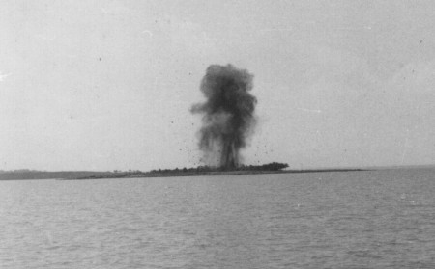
Japanese UXB's on South Shell Island, Darwin Harbour

Another task that was carried out by "ARALUEN" was ammunition dumping and this was somewhat of a farce as there was no Continental shelf in the Northern Territory area that "ARALUEN" could reach effectively. The area given for the dump was not very deep so I would "wander" a little till I found a 'reasonable' hole some distance NW of Charles Point and do the dumping there. No doubt, that in the future someone will snag some of that ammunition and questions will be raised as munitions were usually dumped beyond the Continental shelf and that Shelf was a long, long way from Darwin.

My time in Darwin was coming to a close and word had been received that I would be posted to 4 Water Transport Troop at Chowder Bay in Sydney. Darwin was a learning ground that made Chowder Bay look sick by comparison. Darwin of the 1950's was a natural boom waiting to happen and I wanted to be part of it. It was unfortunate that the infrastructure necessary was not in place at that time. In retrospect, if we had a craft larger than "ARALUEN", then it was quite possible (in fact I am sure) that the Army would have been entrenched in the NT a lot earlier that it is to be.

